WELCOME!
Thanks for singing up with Owen's Hiking And Adventures for a unique adventure in Niagara!
-Your Guide:
Okay, so you probably want to know the person you're going out into the woods with! My name is Owen Bjorgan, and I'm a Niagara On The Lake local who is passionate, skilled, and constantly excited by the great outdoors. I acquired my BSc in Biodiversity from the University of Guelph in 2016, so I studied everything from polar bears to moss to vipers, plus climate and geography.
I believe that the best learning and life experiences happen in “the field”, and my time in Niagara's outdoors since I was a little kid has taught me the most. My adventures in Niagara have pushed me to far corners of the world, including the Amazon, Australia, the Appalachian Mountains and the Everglades, to show people the powers of exploring natural areas and how important nature is for both wildlife and society alike. The best way to do this is through fun and adventure!
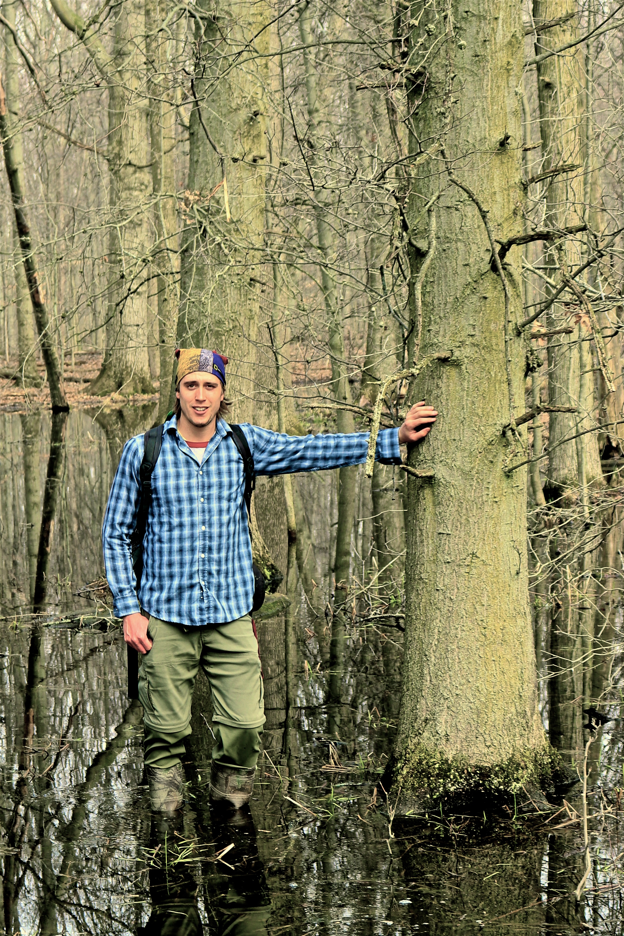
The non-profit wing I operate is where I use environmental projects to raise awareness and funds about conservation. I'm an official Ted Talk speaker, have released four independent nature documentaries called “Hidden Corners”, and solo hiked the 885 km Bruce Trail raising over $27,000 for charities; this trail runs through many of the areas we can explore together!
I am also fortunate to write a nature column for The NOTL Local newspaper, and worked 5 years as an outdoor educator for the school board. I'm currently back in school to become a certified high school biology and geography teacher.
Nothing makes me happier than meeting new people and showing them Niagara's big backyard in an exciting, safe and memorable way. I am also a firm believer in the power of conservation and doing things local, so my tours are meant to be eco-friendly and support small-scale wineries, breweries, and eateries of Niagara.
-Rules and Guidelines:
My rules are pretty traditional: “take nothing but photographs, and leave only footprints”. Easy!
Additionally, making sure you are fully enjoying yourself and safe in Niagara's outdoors is my top priority.
Please note actions or behaviours that are disallowed during the tours: reckless harm towards animals or ecosystems, littering, and bad attitudes (bad attitudes scare the wildlife away!).
Please stay within eyesight of your guide.
You must drive your own vehicle to and from the destination(s).
-Packing and Clothing Recommendations:
Please check the weather in advance, including the morning of the hike. Your guide is always monitoring the weather. The tour operates rain or shine, and will only be cancelled/rescheduled based on dangerous weather and resulting conditions. If the weather is looking rough on the morning of the tour, I will contact you to discuss options. If you are canoeing with me, I have all of the canoes, life jackets, and all other necessary gear.
Recommended packing list for a general hiking day in Niagara:
1) close-toed shoes that can get muddy
2) appropriate clothing for temperature or rain
3) mosquito repellent and sunscreen (I have extras if needed)
4) your own reusable water bottle
5) lunch and snacks (if you're buying/carrying your own)
6) change of socks
7) toilet paper
8) camera
...Swim suits and boots will be advised if needed. Backpacks and ponchos are available for rent- please inquire.
Recommended packing list for a general paddling day in Niagara:
It's the exact same as hiking, listed above, plus
1) footwear that can become wet, submerged or muddy
2) a hat or head covering

See you soon! Thank you- if you have any questions, please contact me.
(289) 407 5537, ohikingadventures@gmail.com

